**-**

**NETWORKING**

**INTRODUCTION TO COMPUTER NETWORKING**

**NETWORK**

A group of two or more similar things or people interconnected with each other is called network. Some of the examples of network in our everyday life includes.

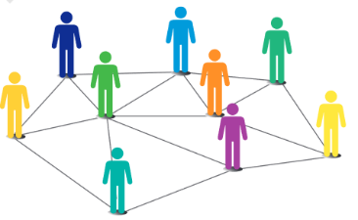• Social network

• Mobile network

• Network of computers

• Airlines, railway, banks, hospitals networks

**COMPUTER NETWORK**

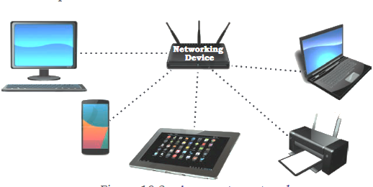

Computer networking refers to interconnected computing devices that can exchange data and share resources with each other.

These networked devices use a system of rules, called communications protocols, to transmit information over physical or wireless technologies.

.

**EVOLUTION OF NETWORKING**

In the 1960s a research project was commissioned by Advanced Research Projects Agency Network (ARPANET) in the U.S. Department of Defence to connect the academic and research institutions located at different places for scientific collaborations. The first message was communicated between the University of California, Los Angeles (UCLA) and Stanford Research Institute (SRI). Slowly but gradually, more and more organisations joined the ARPANET, and many independent smaller networks were formed.

**Types of Network**

1. **Based on the geographical area**
2. PAN ( Personal Area Network)
3. LAN (Local Area Network)
4. MAN (Metropolitan Area Network)
5. WAN (Wide Area Network)

**(b) Based on Architecture .**

1. Server based
2. Peer to peer

**BASED ON GEOGRAPHICAL AREA**

* **PAN ( Personal Area Network)**
* 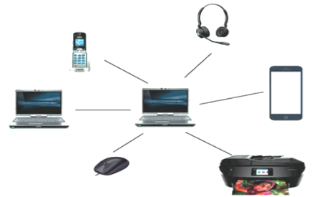A Personal Area Network (PAN) is a network that connects devices located around a single person, typically within a range of a few meters.
* PANs are designed to facilitate communication and data sharing between personal devices, such as smartphones, laptops, tablets, wearable devices, and peripherals like printers and headphones
* PANs typically cover a short range, usually within a radius of 10 meters or less. This limited range ensures that only devices in close proximity can communicate with each other.
* Bluetooth is one of the most widely used technologies for PANs.
* Security is a crucial consideration in PANs, especially since devices are in close proximity to each other.
* 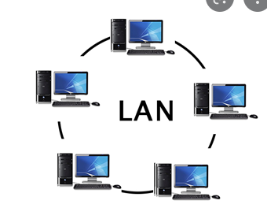**Local Area Network (LAN)**
* Within same building/ campus - up to a few KMS.
* Control the network privately under local administration.
* Normally broadcast type.
* Connect physically adjacent devices.
* Data Transmission rate – 10/100 mbps.
* Uses IEEE 802 standards. (Institute of Electrical and Electronics Engineers.)
* Low Cost.
* **Campus Area Network**

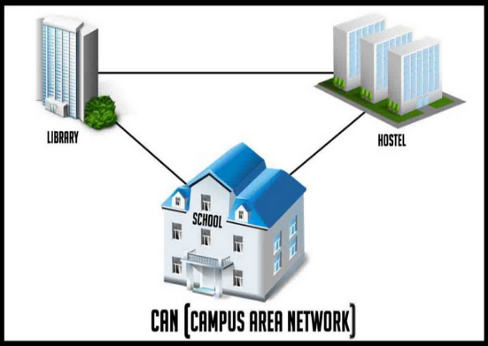

* + - A campus area network (can) is a computer network made up of an interconnection of local area networks within a limited geographical area.
    - It connects two or more LAN within a campus.
    - It is larger than a local area network but smaller than a wide area network.
    - Covers privately owned campus with an area of organization.
    - High cost.
* 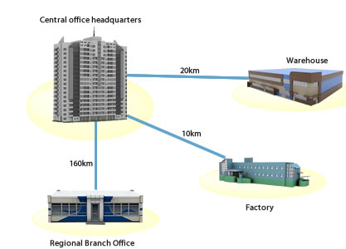**Metropolitan Area Network**
* A metropolitan area network (MAN) is a network that connects two or more local area networks of campus area networks together but does not extend beyond the boundaries of the immediate town/city.
* Router, switches and hubs are connected to create a metropolitan area network.
* It covers large area than campus area network but small area than wide area network.
* Data transmission rate – variable.
* High cost.
* 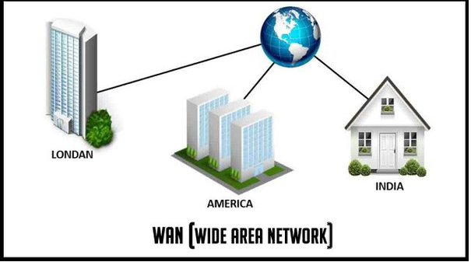**Wide Area Network**
* A wide area network (also known as WAN), is **a large network of information that is not tied to a single l ocation**. WANs can facilitate communication, the sharing of information and much more between devices from around the world through a WAN provider
* High cost.

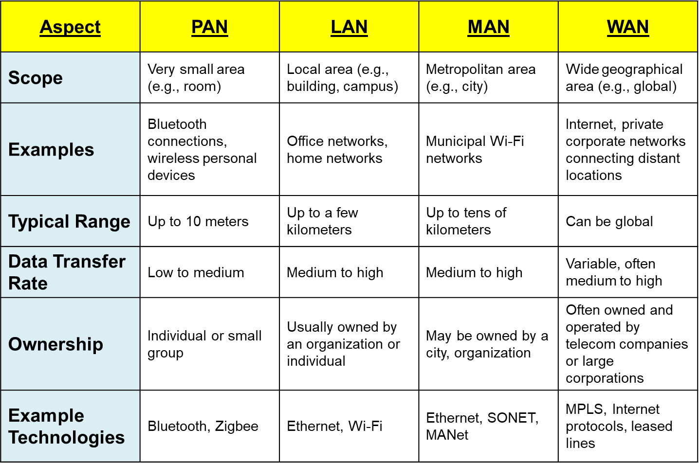**Difference bw PAN, LAN, MAN & WAN**

**NETWORK ON THE BASE OF ARCHITECTURE**

(a) Server based Network

(b) Peer – to – Peer Network

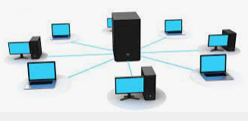**Server based Network**

1. It is network architecture in which each computer or process on the network is either a client or a server.
2. Server are powerful computers or processor dedicated to managing disk drivers, printers or network traffic.
3. Clients are PCs on which user run application.
4. Clients depend on servers for resources.

|  |  |
| --- | --- |
| **Advantage** | **Disadvantage** |
| 1. Data centralized stored. 2. High level security provider. 3. Scalability – easy to expand your network without any problem entire the network. 4. Flexibility – easy to adding & removing without any problem entire the network. 5. Interoperability – all the components work together (server, client & network). 6. Easy to administration – easy to manage & controlled in your network**.** | 1. Costly – Server based networking is required high configuration devices and OS is very costly. So server based network is very costly. 2. Dependency – In this network; server become corrupt or crash then overall network will fail. |

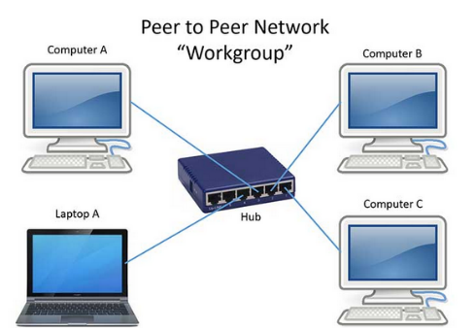

**Peer to Peer Network**

A peer to peer computer network is any network that does not have fixed clients and servers, but a number of peer nodes that function as both clients and servers to the other nodes on the network.

|  |  |
| --- | --- |
| **Advantage** | **Disadvantage** |
| 1. Cheapest (low cost). 2. Small network. 3. Not dependency. 4. Not complexity. | 1. De-centralized data stored. 2. Security less network. 3. Scalability. 4. Manage & control resources is very difficult. |

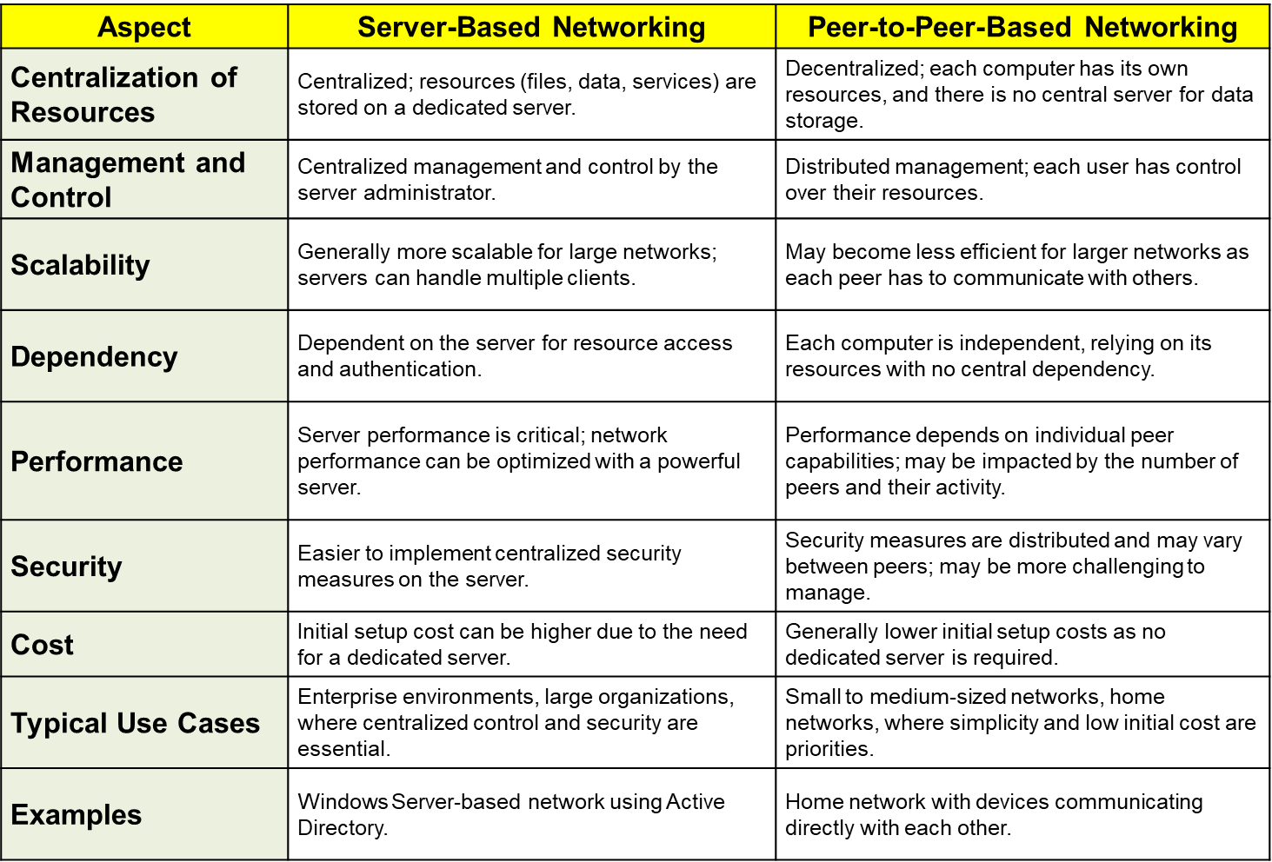

**IP ADDRESSING AND SUBNETTING**

In the context of computers and computer networks, an "address" refers to a unique identifier assigned to a specific entity, such as a device, memory location, or network node. Addresses serve various purposes depending on the context in which they are used. Here are some common types of addresses in computing:

* + **IP Address**: In computer networking, an IP (Internet Protocol) address is a unique numerical label assigned to each device connected to a network that uses the Internet Protocol for communication. IP addresses are used to identify and locate devices on a network, enabling data packets to be routed between them.
  + **MAC Address**: A MAC (Media Access Control) address is a unique identifier assigned to a network interface controller (NIC) for communication on a network. Unlike IP addresses, which can change based on network configuration, MAC addresses are hardcoded into the hardware of the device and provide a permanent, globally unique identifier.

**IP Address**

1. An IP (Internet Protocol) address is a unique numerical label assigned to each device connected to a network that uses the Internet Protocol for communication. An IP address is a 32 bit binary number.
2. IP addresses serve as identifiers for devices on a network, enabling them to send and receive data packets to and from other devices. They are essential for routing data across networks and ensuring that it reaches its intended destination. It is the range 0 to 255 (known as octets) separated by decimal points.
3. IP addresses are typically represented as a series of four numbers separated by periods, such as "192.168.1.1." Each number, known as an octet, can range from 0 to 255, allowing for a total of approximately 4.3 billion unique IP addresses. Example 140.179.200.250
4. There are two main types of IP addresses: IPv4 and IPv6. IPv4 addresses, which are the most commonly used, consist of 32 bits and are expressed in the dotted-decimal notation described above. IPv6 addresses, introduced to address the depletion of available IPv4 addresses, consist of 128 bits and are expressed in hexadecimal notation.
5. IP addresses can be assigned dynamically or statically. With dynamic IP addressing, devices are assigned IP addresses dynamically by a DHCP (Dynamic Host Configuration Protocol) server when they connect to a network. With static IP addressing, devices are assigned a specific IP address that does not change over time.
6. Every IP address consists of two parts.
   * + One identifying the network.
     + Second identifying the host.

**Classes of IP Address**

IP addresses are categorized into different classes based on the range of values in their first octet. These classes, designated as A, B, C, D, and E, were part of the original IPv4 addressing scheme. Each class has a different range of IP addresses and is intended for specific purposes. Here's an overview of the classes of IP addresses:

1. **Class A**:
   * Range: 1.0.0.0 to 126.255.255.255
   * Subnet Mask: 255.0.0.0
   * Characteristics: Class A addresses have a leading bit pattern of 0, allowing for 128 networks and a large number of hosts per network (approximately 16.7 million). Class A addresses are typically assigned to large organizations or Internet Service Providers (ISPs).
2. **Class B**:
   * Range: 128.0.0.0 to 191.255.255.255
   * Subnet Mask: 255.255.0.0
   * Characteristics: Class B addresses have a leading bit pattern of 10, allowing for 16,384 networks and a moderate number of hosts per network (approximately 65,000). Class B addresses are commonly assigned to medium-sized organizations.
3. **Class C**:
   * Range: 192.0.0.0 to 223.255.255.255
   * Subnet Mask: 255.255.255.0
   * Characteristics: Class C addresses have a leading bit pattern of 110, allowing for 2,097,152 networks and a smaller number of hosts per network (up to 254). Class C addresses are often assigned to small organizations or individual users.
4. **Class D**:
   * Range: 224.0.0.0 to 239.255.255.255
   * Characteristics: Class D addresses are reserved for multicast addresses, which are used for one-to-many or many-to-many communication. Multicast addresses allow a single packet to be sent to multiple recipients simultaneously.
5. **Class E**:
   * Range: 240.0.0.0 to 255.255.255.255
   * Characteristics: Class E addresses are reserved for experimental or research purposes and are not intended for general use. They are not allocated for public or private networks.

**No of Host & Networks in different Class**

1. **Class A**:
   * Range: 1.0.0.0 to 126.255.255.255
   * Subnet Mask: 255.0.0.0
   * Number of Networks: 128
   * Number of Hosts per Network: Approximately 16.7 million
2. **Class B**:
   * Range: 128.0.0.0 to 191.255.255.255
   * Subnet Mask: 255.255.0.0
   * Number of Networks: 16,384
   * Number of Hosts per Network: Approximately 65,000
3. **Class C**:
   * Range: 192.0.0.0 to 223.255.255.255
   * Subnet Mask: 255.255.255.0
   * Number of Networks: 2,097,152
   * Number of Hosts per Network: Up to 254
4. **Class D** (Reserved for multicast addresses):
   * Range: 224.0.0.0 to 239.255.255.255
   * Characteristics: Not used for defining networks or hosts. Reserved for multicast group communication.
5. **Class E** (Reserved for experimental or research purposes):
   * Range: 240.0.0.0 to 255.255.255.255
   * Characteristics: Not used for defining networks or hosts. Reserved for experimental purposes and not allocated for public or private networks.

**Two different devices can never have same IP addresses in the same network**

Class ‘A’ consists of 8 bit network Id and 24 bit host Id.

Each network in class A will have 224 =16,777,216 number of host.

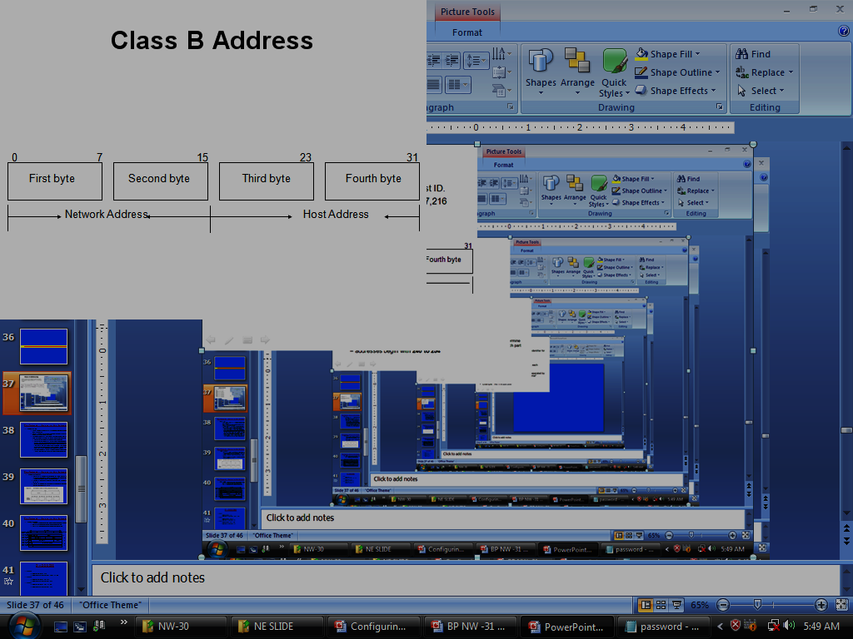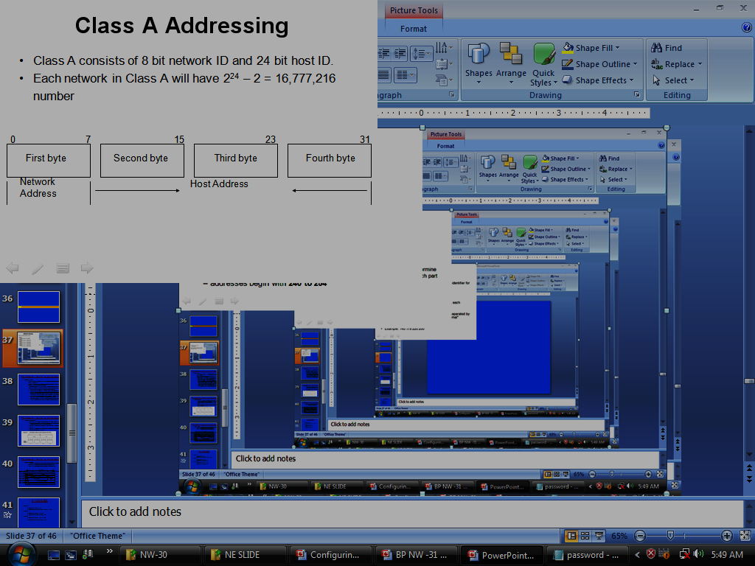

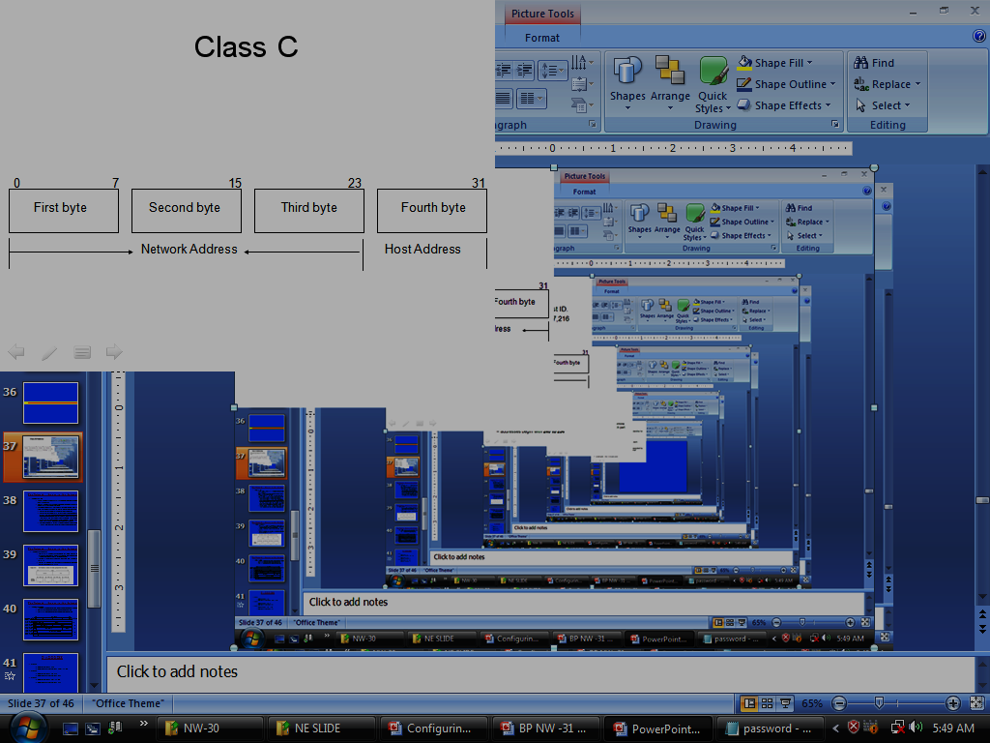

**How to determine Network and host number?**

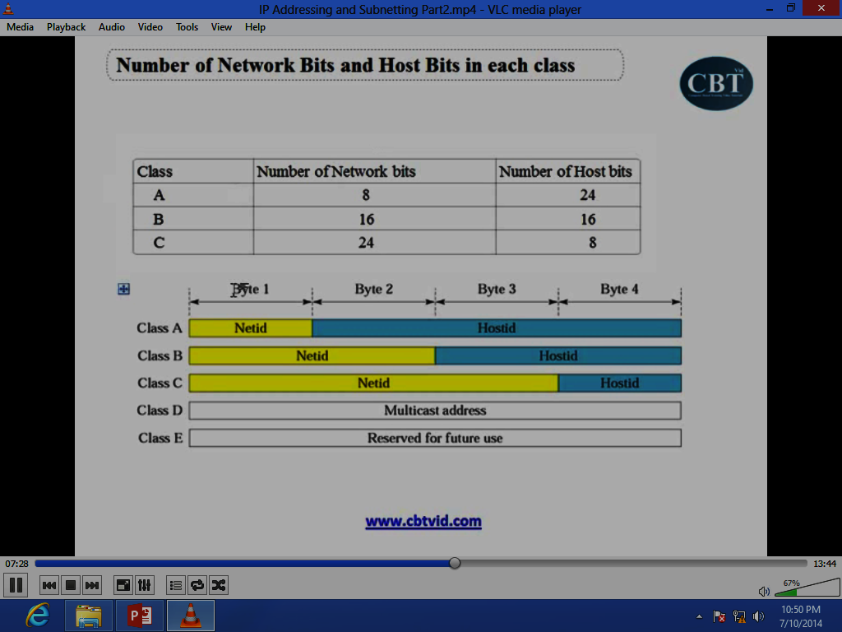

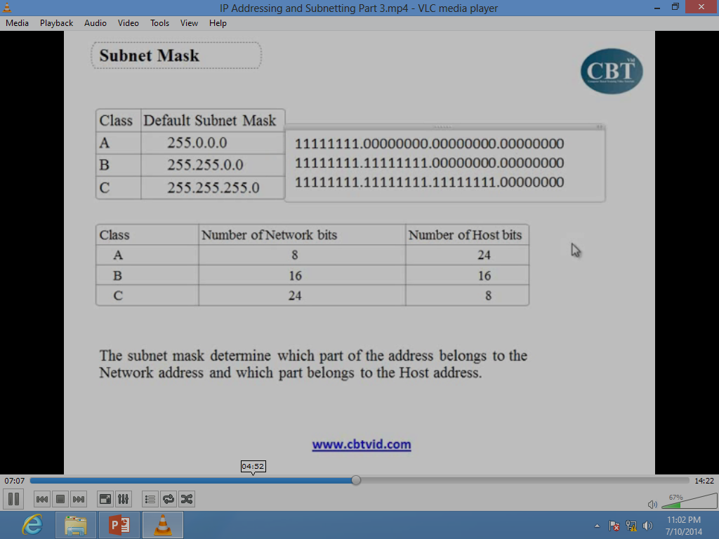

**Number of zero in the subnet mask represents the host bits in the IP address**

**IP Address scheme**

1. The valid addresses in class a start from 1 to 126.
2. Network 0.0.0.0 is defined for use as a broadcast address.
3. Addresses beginning with 127, are reserved for loopback and for internal testing on a local machine.
4. Class ‘D’ addresses are used for multicasting.
5. Class ‘E’ addresses are reserved for future use. They should not be used for host addresses.

**Public and Private IP Address**

Public and private IP addresses are used within computer networks to facilitate communication between devices, both within private networks and over the public Internet. Here's an explanation of each:

1. **Public IP Address**:
   * A public IP address is an address assigned to a device that is directly accessible from the Internet.
   * These addresses are unique globally and are routable on the public Internet.
   * Public IP addresses are typically assigned by Internet Service Providers (ISPs) or network administrators.
   * They are used for communication between devices on different networks and for accessing resources or services over the Internet.
   * Examples of devices with public IP addresses include web servers, email servers, and routers that connect directly to the Internet.
2. **Private IP Address**:
   * A private IP address is an address assigned to a device within a private network, such as a home or business network.
   * These addresses are not routable on the public Internet and are intended for use within the confines of a private network.
   * Private IP addresses are typically assigned according to specific ranges reserved for private use, as defined by the Internet Engineering Task Force (IETF) in RFC 1918.
   * The most commonly used private IP address ranges are:
     + Class A: 10.0.0.0 to 10.255.255.255 (subnet mask: 255.0.0.0)
     + Class B: 172.16.0.0 to 172.31.255.255 (subnet mask: 255.240.0.0)
     + Class C: 192.168.0.0 to 192.168.255.255 (subnet mask: 255.255.0.0)
   * Private IP addresses are used for communication between devices within the same private network, such as computers, printers, and smartphones connected to a home Wi-Fi network.

|  |  |  |  |
| --- | --- | --- | --- |
| **CLASS** | **CLASS RANGE** | **PRIVATE IP** | **PUBLIC IP** |
| A | 1.0.0.0 to  126.255.255.255 | 10.0.0.0 to  10.255.255.255 | 1.0.0.0 TO  9.255.255.255  11.0.0.0 to  126.255.255.255 |
| B | 128.0.0.0 to  191.255.255.255 | 172.16.0.0 to  172.31.255.255 | 128.0.0.0 to  172.15.255.255  172.32.0.0 to  191.255.255.255 |
| C | 192.0.0.0 to  223.255.255.255 | 192.168.0.0 to  192.168.255.255 | 192.0.0.0 to 192.167.255.255  192.169.0.0 to  223.255.255.255 |

**SUBNETTING**

**Problem**: Organizations have multiple networks which are independently managed

1. **Solution 1**: Allocate an address for each network
   * + Difficult to manage
     + From the outside of the organization, each network must be addressable i.e. have an identifiable address.
2. **Solution 2**: Add another level of hierarchy to the IP addressing structure

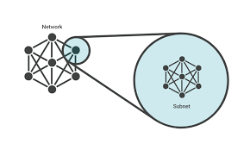Subnetting is the process of dividing a single large network into multiple smaller subnetworks, or subnets. This practice offers several benefits, including efficient utilization of IP addresses, improved network performance, and enhanced security. Subnetting is a fundamental concept in IP networking and is commonly used in both small and large-scale network deployments

**Basic idea of Subnetting**

1. Split the host number portion of an IP address into a subnet number and a (smaller) host number.
2. Result is a 3-layer hierarchy.

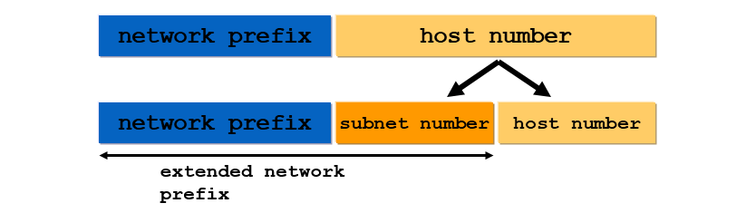

**Then**:

* 1. Subnets can be freely assigned within the organization.
  2. Internally, subnets are treated as separate networks.
  3. Subnet structure is not visible outside the organization.

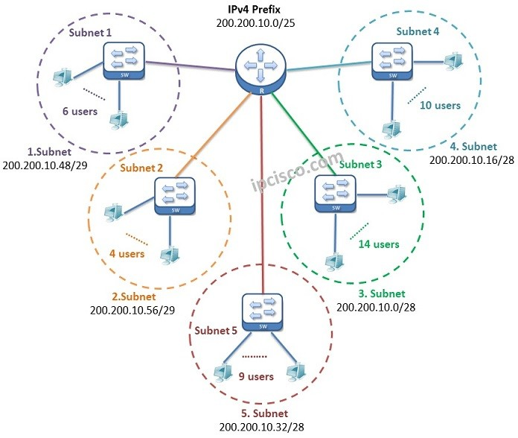**Example of a Subnetting plan**

**Advantage of Subnetting**

1. **Efficient Use of IP Addresses**: Subnetting allows for the efficient allocation of IP addresses by dividing a single large network into smaller subnetworks. This helps conserve IP address resources, especially in scenarios where the available address space is limited.
2. **Improved Network Performance**: By dividing a large network into smaller subnets, subnetting reduces the size of broadcast domains and limits the scope of broadcast traffic. This helps minimize network congestion and improves overall network performance by reducing unnecessary traffic on the network segments.
3. **Enhanced Security**: Subnetting facilitates network segmentation, which allows for the isolation of different parts of the network from each other. By segmenting the network into smaller subnets, organizations can implement security policies and access controls more effectively, thereby enhancing network security.
4. **Simplified Network Management**: Subnetting simplifies network management by breaking down a complex network into smaller, more manageable segments. Each subnet can be managed independently, allowing network administrators to apply specific configurations, policies, and settings tailored to the needs of each subnet.
5. **Flexibility and Scalability**: Subnetting provides flexibility and scalability in network design and deployment. Organizations can easily expand their networks by adding additional subnets as needed without the need to reconfigure the entire network infrastructure. This scalability allows networks to adapt to changing requirements and growth over time.
6. **Optimized Routing and Traffic Control**: Subnetting enables more efficient routing and traffic control within the network. By dividing the network into smaller subnets, routing tables can be optimized to route traffic more effectively between subnets, leading to faster and more reliable communication between devices.
7. **Support for Virtual LANs (VLANs)**: Subnetting is often used in conjunction with Virtual LANs (VLANs) to further segment and organize network traffic. VLANs allow devices in different subnets to be grouped together logically, regardless of their physical location, providing greater flexibility and control over network traffic.
8. **Better Resource Allocation**: Subnetting allows organizations to allocate network resources more effectively by dedicating specific subnets to particular departments, teams, or functions within the organization. This helps streamline resource allocation and optimize network performance based on the unique requirements of each subnet.

**Subnetting example:**

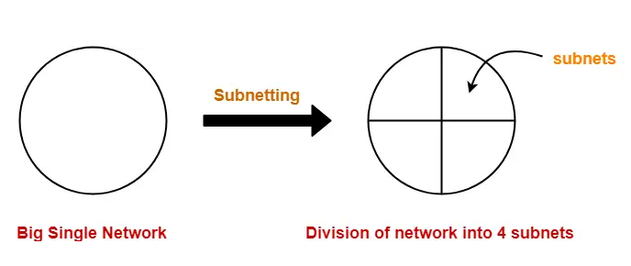

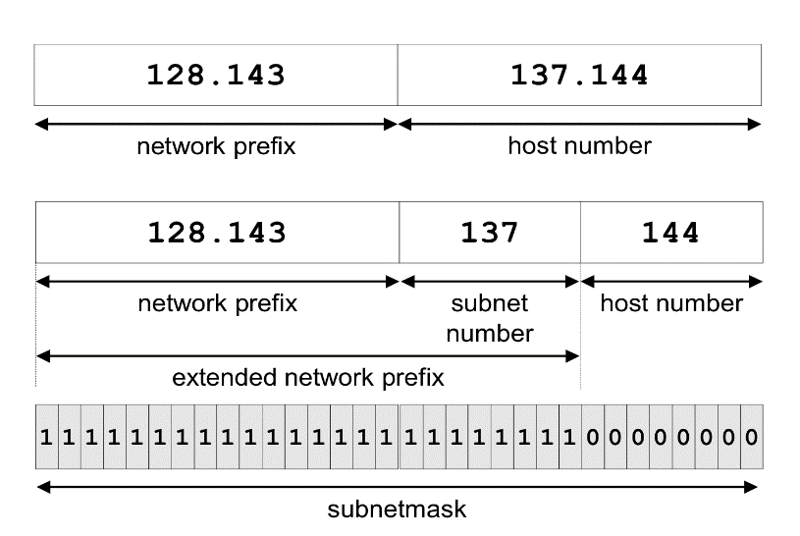

**Network without Subnets**

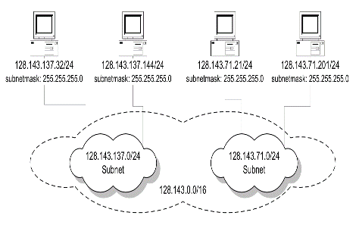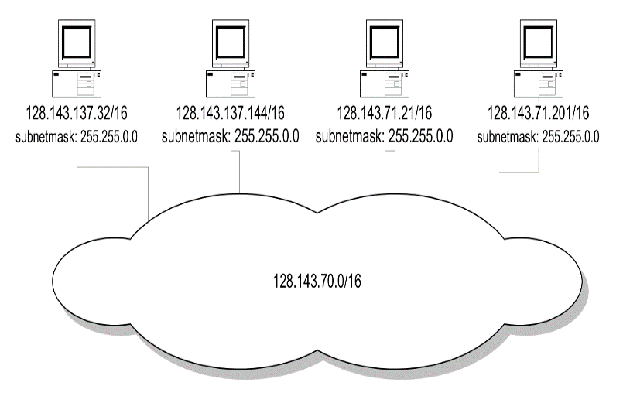

**Same Network with Subnets**

**Same Network with different subnet mask**

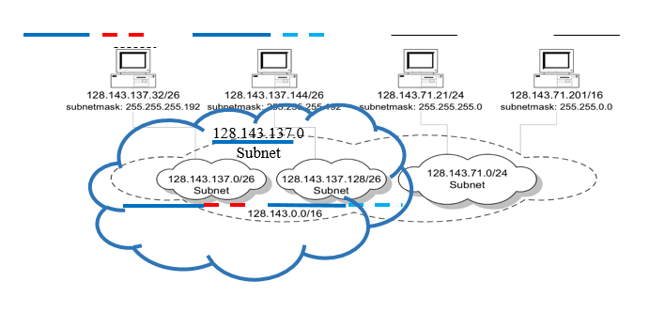

**Subnet example**

An organization with 4 departments has the following IP address space: 10.2.22.0/23. As the systems manager, you are required to create subnets to accommodate the IT needs of 4 departments. The subnets have to support to 200, 61, 55, and 41 hosts respectively. What are the 4 subnet network numbers?

**Solution:**

* 1. 10.2.22.0/24 (256 addresses > 200).
  2. 10.2.23.0/26 (64 addresses >61).
  3. 10.2.23.64/26 (64 addresses > 55).
  4. 10.2.23.128/26 (64 addresses > 41).

**Subnetting and Classless Inter Domain Routing (CIDR)**

Subnetting is done by allocating some of the leading bits of the host number to indicate a subnet number.

1. With sub netting, the network prefix and the subnet number make up an extended network prefix.
2. The extended prefix can be expressed in terms of a subnet mask or, using CIDR notation, by adding the length of the extended subnet mask after the IP address.

For example, for Argon, the first byte of the host number (the third byte of the IP address) is used to denote the subnet number.

* 1. 128.143.0.0/16 is the IP address of the network (network prefix /16),
  2. 128.143.137.0/24 is the IP address of the subnet.
  3. 128.143.137.144/32 is the IP address of the host.
  4. 255.255.255.0 is the subnet mask of the host (or subnet prefix /24).

**Types of Subnetting**

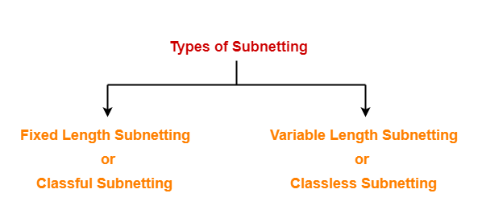

## **1. Fixed Length Subnetting-**

 Fixed length subnetting also called as **classful subnetting** divides the network into subnets where-

* All the subnets are of same size.
* All the subnets have equal number of hosts.
* All the subnets have same subnet mask.

## **2. Variable Length Subnetting-**

 Variable length subnetting also called as **classless subnetting** divides the network into subnets where-

* All the subnets are not of same size.
* All the subnets do not have equal number of hosts.
* All the subnets do not have same subnet mask.

**IP VERSION 6**

IPv6, or Internet Protocol version 6, is the most recent version of the Internet Protocol (IP), which serves as the foundation for communication on the Internet. IPv6 was developed to address the limitations of its predecessor, IPv4, and to accommodate the growing number of devices and addresses required by the expanding Internet. Here's an overview of IPv6:

1. **Address Space**: One of the most significant features of IPv6 is its significantly larger address space compared to IPv4. IPv6 addresses are 128 bits long, allowing for approximately 3.4×10^38 unique addresses. This vast address space ensures an abundant supply of addresses to accommodate the proliferation of devices connected to the Internet, including smartphones, computers, IoT devices, and more.
2. **Address Representation**: IPv6 addresses are represented in hexadecimal notation, consisting of eight groups of four hexadecimal digits separated by colons (e.g., 2001:0db8:85a3:0000:0000:8a2e:0370:7334). To simplify address representation and reduce the length of IPv6 addresses, consecutive groups of zeros within an address can be abbreviated with a double colon (::) once in an address.
3. **Enhanced Security**: IPv6 incorporates features to enhance network security, including built-in support for IPsec (Internet Protocol Security), which provides encryption, authentication, and integrity protection for IPv6 packets. IPsec can be used to secure communication between devices and protect against various network-based threats, such as eavesdropping and tampering.

**Notation of IPV 6 addresses**

1. Convention: The 128-bit IPv6 address is written as eight 16-bit integers (using hexadecimal digits for each integer) CEDF:BP76:3245:4464:FACE:2E50:3025:DF12
2. Short notation:
3. Abbreviations of leading zeroes:
4. CEDF:BP76:0000:0000:009E:0000:3025:DF12 🡪 CEDF:BP76:0:0:9E :0:3025:DF12
5. “:0000:0000” can be written as “::”
6. CEDF: BP76:0:0: FACE: 0:3025:DF12 🡪 CEDF: BP76: FACE: 0:3025:DF12
7. IPv6 addresses derived from IPv4 addresses have different formats. Convention allows to use IPv4 notation for the last 32 bits.
   1. 128.143.137.144 -> 0:0:0:0:0:ffff:808F:8990 or
   2. 128.143.137.144 -> 2002:808f:8990:0:0:0:0:0 (called 6to4 address)

**IPv6 Header**

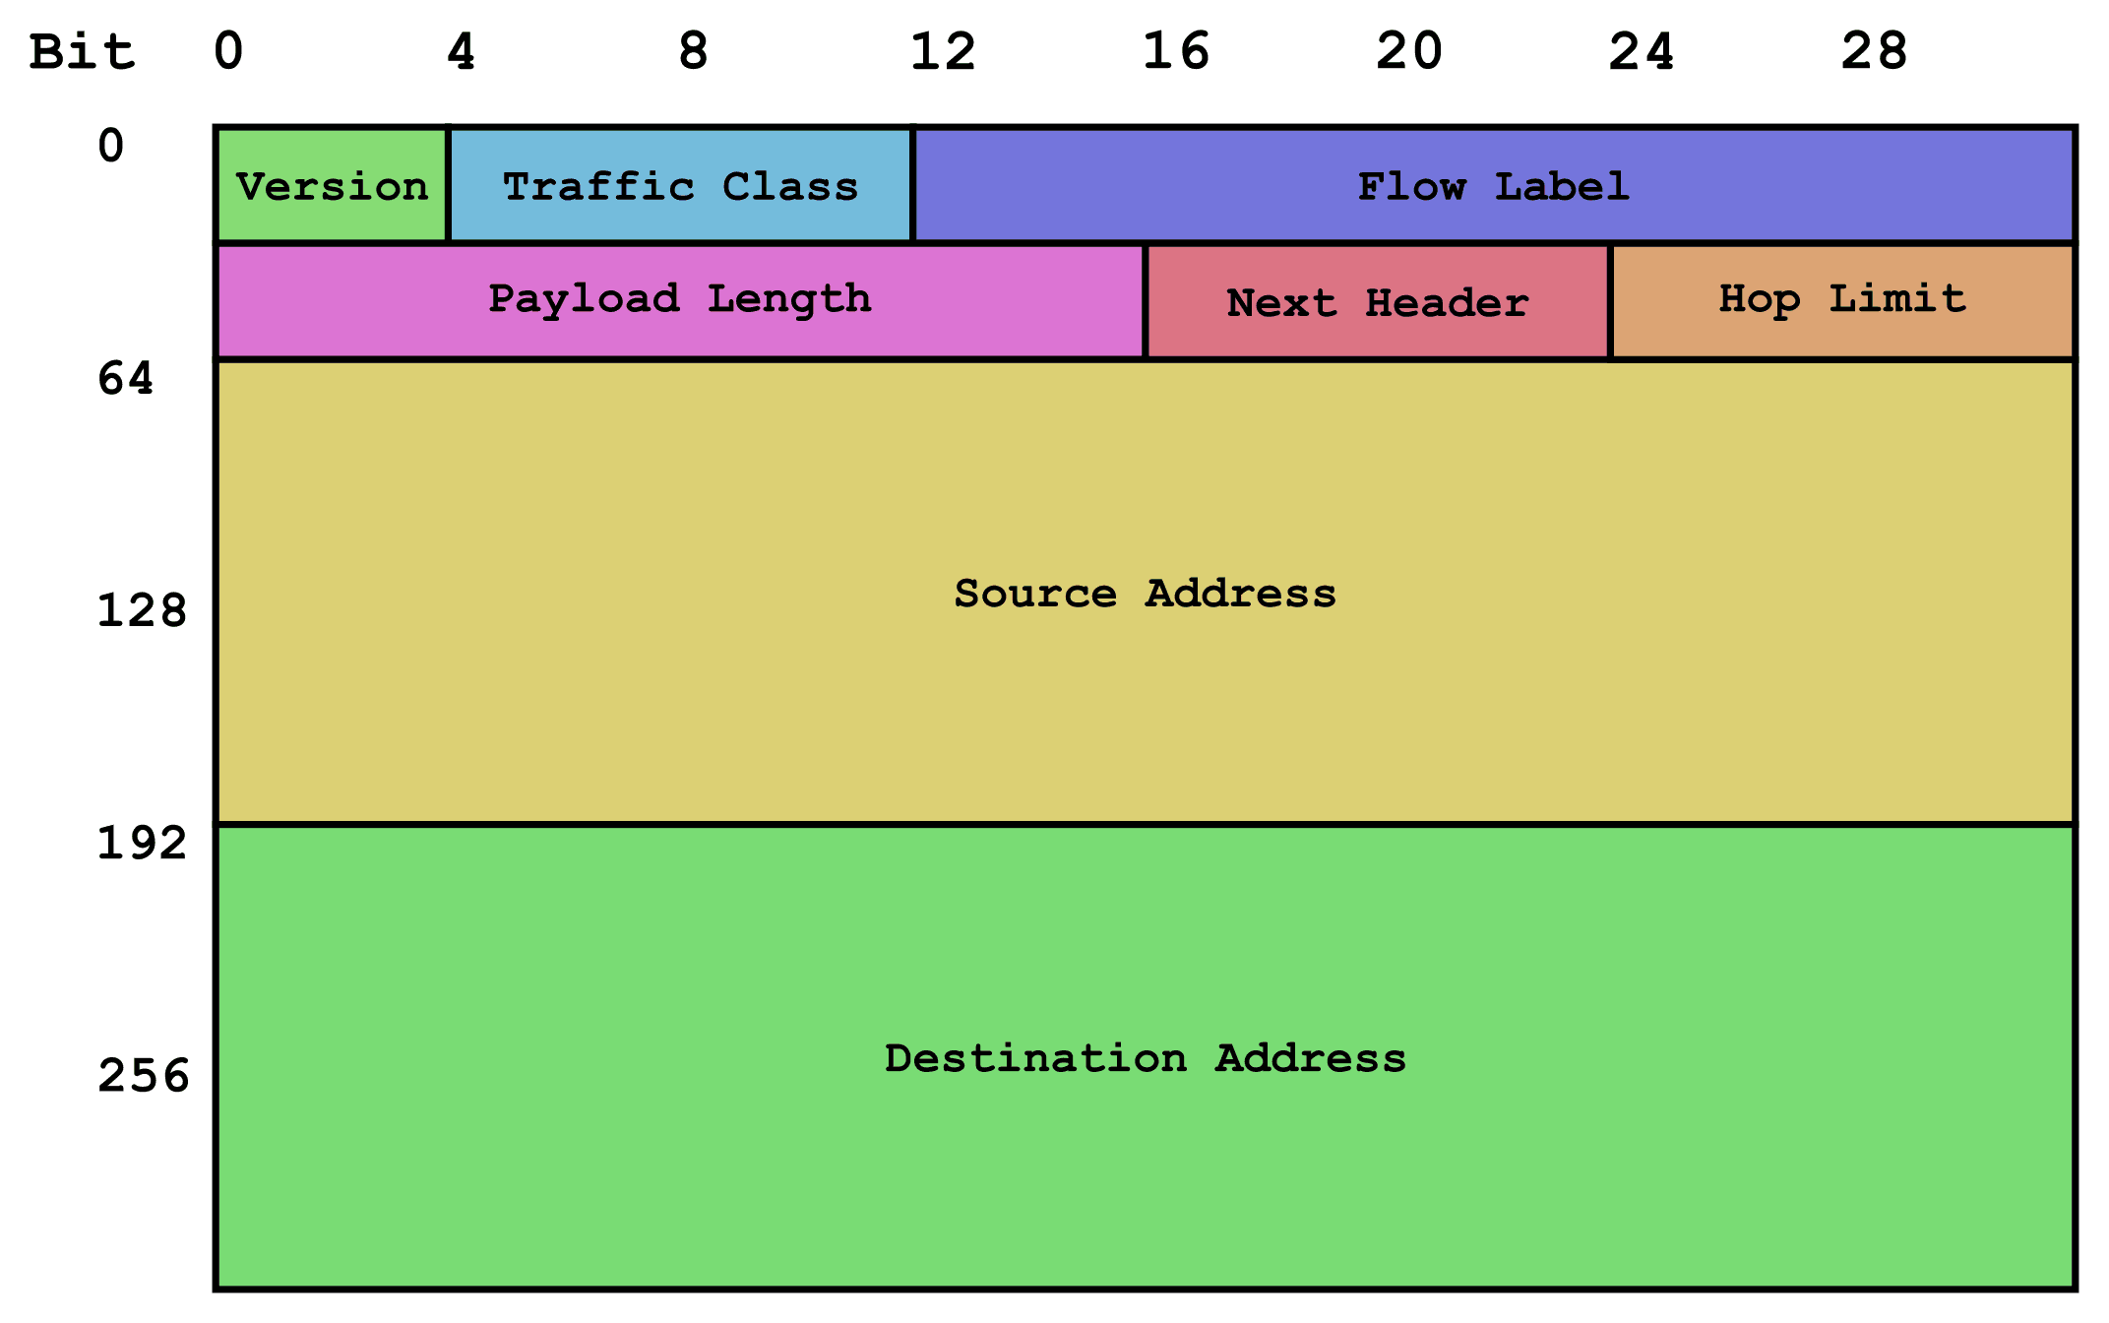

**PROTOCOLS**

**Difference between IPv4 & IPv6**

|  |  |  |
| --- | --- | --- |
| **Feature** | **IPv4** | **IPv6** |
| Address Format | 32 bits, decimal format (e.g., 192.0.2.1) | 128 bits, hexadecimal format (e.g., 2001:0db8:85a3:0000:0000:8a2e:0370:7334) |
| Address Space | Approximately 4.3 billion unique addresses | Approximately 3.4×10^38 unique addresses |
| Address Autoconfiguration | Manual or DHCP-based | Stateless address autoconfiguration (SLAAC) |
| Built-in Security | Optional extensions (e.g., IPsec) | Built-in support for IPsec |
| Quality of Service (QoS) | Limited support, requires additional protocols | Native support for QoS functionality |
| Header Format | 20 bytes (without options) or more, includes various fields | Fixed at 40 bytes, includes streamlined fields |
| Migration Challenges | Address exhaustion, IPv4 to IPv6 transition | Compatibility issues, lack of IPv6 support |

**CONDUCT OF VIDEO CONFERENCE IN INDIAN ARMY**

Video conferencing is a technology that enables individuals or groups of people in different locations to communicate with each other in real-time using video and audio transmission over the internet. It allows participants to see and hear each other as if they were in the same room, facilitating remote collaboration, meetings, and communication.

Video conferencing has become increasingly important in various aspects of modern life, both professionally and personally. Here are some key reasons why video conferencing is important:

1. **Remote Collaboration**: Video conferencing enables teams to collaborate effectively regardless of their physical locations. It allows remote workers, distributed teams, and global partners to communicate in real-time, fostering collaboration, creativity, and productivity.
2. **Cost Savings**: Video conferencing reduces the need for travel, resulting in significant cost savings for organizations. By replacing in-person meetings with virtual ones, companies can save money on travel expenses, accommodation, and other associated costs.
3. **Time Efficiency**: Video conferencing saves time by eliminating the need for travel and reducing meeting setup time. Participants can join meetings from anywhere with an internet connection, enabling quick decision-making and faster project execution.
4. **Increased Flexibility**: Video conferencing offers flexibility in scheduling meetings, allowing participants to join from different time zones and accommodate varying schedules. This flexibility improves accessibility and inclusivity, enabling more people to participate in meetings and events.
5. **Improved Communication**: Video conferencing provides a richer communication experience compared to audio-only or text-based communication methods. Participants can see each other's facial expressions, body language, and visual aids, leading to better understanding and more effective communication.
6. **Enhanced Engagement**: Video conferencing promotes engagement and interaction among participants, leading to more dynamic and productive meetings. Features such as screen sharing, virtual whiteboards, and chat functionality facilitate collaboration and brainstorming.
7. **Remote Learning and Training**: Video conferencing is used extensively in education and training settings to deliver remote learning experiences. It allows students to attend classes from anywhere, access educational resources, and interact with instructors and peers in real-time.
8. **Global Reach**: Video conferencing enables organizations to connect with partners, clients, and customers worldwide, expanding their reach and market opportunities. It facilitates international business relationships, cross-cultural collaboration, and global expansion efforts.
9. **Crisis Response and Business Continuity**: Video conferencing plays a critical role in crisis response and business continuity planning. During emergencies such as natural disasters or pandemics, organizations can use video conferencing to maintain communication, coordinate response efforts, and ensure operational continuity.
10. **Environmental Impact**: By reducing the need for travel, video conferencing helps minimize carbon emissions and environmental impact. It supports sustainability initiatives and contributes to efforts to reduce the carbon footprint associated with business operations.

**IMPORTANCE OF VC IN INDIAN ARMY**

Video conferencing plays a crucial role in the Indian Army, providing a means for communication, collaboration, and coordination among personnel stationed in different locations.

1. **Remote Meetings and Briefings**: Video conferencing allows commanders, officers, and other personnel to conduct remote meetings and briefings, enabling them to discuss strategy, tactics, and operational plans without the need for physical presence. This is particularly useful for personnel deployed in remote or inaccessible areas.
2. **Training and Education**: The Indian Army uses video conferencing for training and educational purposes, including delivering lectures, conducting virtual classrooms, and providing remote training sessions to soldiers and officers across different locations. This facilitates continuous learning and skill development among personnel.
3. **Operational Coordination**: Video conferencing enables real-time communication and coordination among units and command centers during military operations, exercises, and drills. It allows commanders to monitor and coordinate activities, share intelligence, and make decisions promptly based on the latest information.
4. **Logistics and Supply Chain Management**: Video conferencing is used for logistics and supply chain management within the Indian Army, allowing personnel to coordinate the movement of troops, equipment, and supplies efficiently. It helps streamline logistics operations and ensures timely delivery of resources to support military activities.
5. **Strategic Planning and Decision Making**: Video conferencing facilitates strategic planning and decision-making processes within the Indian Army by bringing together key stakeholders and decision-makers from different locations. It allows senior officials to discuss strategic matters, assess situational updates, and make informed decisions collaboratively.
6. **Interagency Collaboration**: Video conferencing enables collaboration and coordination between the Indian Army and other branches of the armed forces, as well as with government agencies, security organizations, and international partners. It supports joint exercises, interoperability, and information sharing for enhanced security and defense capabilities.
7. **Emergency Response and Disaster Management**: During emergency situations, natural disasters, or humanitarian crises, video conferencing enables rapid response and coordination efforts by the Indian Army. It allows commanders to assess the situation, deploy resources, and coordinate relief operations effectively to mitigate the impact of disasters and provide assistance to affected populations.

**Different modes of VC in Indian Army**

* ADN (Army Data Network)
* VR Data
* Internet

**Different application used by Indian Army for VC**

* UTP +
* C-DOT
* Polycom
* Webex
* Google Meet

**UTP +**

* + Unified Telepresence Plus (UTP +)
  + UTP+ is a client-based software
  + Enables you to conference with over a hundred people at once at optimized bandwidth
  + Used on Army Data Network
  + Features:-
    - Audio Management
    - Video Management
    - Video Conferencing
    - Display options
    - Camera Management
    - Sharing and collaboration

**SERVER**

A server is a computer or a system that provides resources, data, services, or functionality to other computers, known as clients, over a network. It could be a physical machine or a virtualized instance running on powerful hardware. Servers are designed to handle specific tasks such as hosting websites, storing and managing data, providing email services, processing requests in a client-server architecture, managing network resources, and much more.

Servers typically have more computing power, memory, and storage capacity compared to regular computers, allowing them to handle multiple requests from clients simultaneously. They are often optimized for reliability, availability, and scalability to ensure that services remain accessible and responsive even during periods of high demand.

Servers can be categorized into various types based on their functions and the services they provide. Here are some common types of servers along with details about their functions:

1. Web Servers:
   * Function: Web servers are designed to host websites and web applications, serving web pages to clients (usually web browsers) upon request.
   * Details: They handle HTTP requests and responses, delivering web content stored on their file systems. Popular web server software includes Apache HTTP Server, Nginx, Microsoft Internet Information Services (IIS), and LiteSpeed.
2. File Servers:
   * Function: File servers store and manage files accessible to users over a network, facilitating file sharing and collaboration within organizations.
   * Details: Users can access files stored on file servers through file transfer protocols such as FTP (File Transfer Protocol), SMB (Server Message Block), NFS (Network File System), or through network shares. File servers often implement access controls to regulate who can access, modify, or delete files.
3. Database Servers:
   * Function: Database servers manage databases and handle requests to retrieve, store, or manipulate data stored in databases.
   * Details: They run database management systems (DBMS) such as MySQL, PostgreSQL, Microsoft SQL Server, Oracle Database, and MongoDB. Database servers support SQL queries and provide mechanisms for data storage, retrieval, indexing, and transaction management. They ensure data integrity, security, and efficient data access.
4. Email Servers:
   * Function: Email servers handle the sending, receiving, and storage of email messages, facilitating electronic communication.
   * Details: Email servers use email protocols such as SMTP (Simple Mail Transfer Protocol), POP3 (Post Office Protocol version 3), IMAP (Internet Message Access Protocol), and others to send and receive emails. They store incoming emails in mailboxes and enable users to access their emails through email clients or webmail interfaces. Examples include Postfix, Sendmail, Microsoft Exchange Server, and Dovecot.
5. Application Servers:
   * Function: Application servers run software applications and provide various services such as application hosting, middleware services, and data integration.
   * Details: They support the execution of custom or off-the-shelf applications, providing a runtime environment for applications to run efficiently. Application servers often include features such as load balancing, clustering, caching, and transaction management to ensure high availability, scalability, and performance.
6. DNS Servers:
   * Function: DNS servers translate domain names (e.g., example.com) into IP addresses, enabling users to access websites using human-readable names.
   * Details: DNS servers maintain distributed databases (DNS zones) containing mappings of domain names to IP addresses. They resolve domain name queries by traversing the DNS hierarchy and querying authoritative DNS servers. DNS servers help route internet traffic and ensure the proper functioning of web services.

**Difference bw Server and Client**

|  |  |  |
| --- | --- | --- |
| **Aspect** | **Server** | **Client** |
| Function | Provides resources, services, or functionality | Requests resources or services |
| Responsibility | Manages and delivers resources or services | Consumes resources or services |
| Resources | Typically has more computing power and storage | Typically has less computing power and storage |
| Role in Communication | Passively waits for incoming requests | Actively initiates communication by sending requests |
| Examples | Web servers, file servers, database servers | Web browsers, email clients, FTP clients |

**ADDS**

Active Directory Domain Services (AD DS) is a core component of the Windows Server operating system. It is a directory service provided by Microsoft that stores information about objects on a network and makes this information available to users and network administrators. AD DS is primarily used to manage identities and resources within a networked environment. Here's a breakdown of its key functionalities:

1. **Directory Services**: AD DS organizes and stores information about network resources such as computers, users, groups, and devices in a hierarchical structure called a directory. This directory is often referred to as the Active Directory database.
2. **Authentication and Authorization**: AD DS provides authentication and authorization services, allowing users to log in to computers and access network resources based on their permissions and privileges. It verifies user credentials during logon and enforces access control policies defined by administrators.
3. • **Group Policy Management**: AD DS enables administrators to define and enforce Group Policies across the network, controlling user and computer configurations, security settings, software installations, and more. Group Policies help ensure consistency and security throughout the network.
4. • **Domain Controller**: AD DS relies on servers called domain controllers to store and replicate directory data, authenticate users, and enforce security policies within a domain. Multiple domain controllers can be deployed within a network for redundancy and fault tolerance.

**DHCP**

Dynamic Host Configuration Protocol (DHCP) is a network management protocol used on TCP/IP networks, such as the Internet and local area networks (LANs), to automatically assign IP addresses and other network configuration parameters to devices on the network. DHCP is particularly useful in environments where manual configuration of network settings is impractical or inefficient.

• **DHCP Server**: A DHCP server is a networked device that dynamically assigns IP addresses and related network configuration information to DHCP clients. In a server environment, a DHCP server typically runs on a dedicated server machine, although it can also be integrated into networking devices such as routers or switches.

• **IP Address Assignment**: When a device (DHCP client) connects to the network and needs an IP address, it sends a DHCP Discover message to discover available DHCP servers on the network. The DHCP server responds with a DHCP Offer message, providing an available IP address from its pool of addresses.

• **Lease Management**: The DHCP server assigns the IP address to the client for a specified lease duration. During this lease period, the client can use the IP address to communicate on the network. The lease duration is configurable on the DHCP server and typically ranges from a few hours to several days.

* **Release**: When a DHCP client no longer requires an assigned IP address, it can voluntarily release the IP address back to the DHCP server by sending a DHCP Release message. This allows the DHCP server to reclaim and reuse the IP address for other clients

**DNS**

Domain Name System (DNS) is a hierarchical decentralized naming system for computers, services, or any resource connected to the Internet or a private network. It translates human-readable domain names (such as [www.example.com](http://www.example.com)) into IP addresses (such as 192.0.2.1), which computers use to identify each other on the network. Here's an overview of how DNS works:

1. **Domain Names**: A domain name is a human-readable label that corresponds to a specific IP address or set of IP addresses. Domain names are organized into a hierarchy, with the top-level domains (TLDs) at the highest level (.com, .org, .net, etc.), followed by second-level domains (example.com, example.org, etc.), and subdomains ([www.example.com](http://www.example.com), mail.example.com, etc.)

**IIS**

Internet Information Services (IIS) is a flexible, secure, and extensible web server created by Microsoft for use with Windows Server operating systems. It's a robust platform for hosting websites, web applications, and services. Here's an overview of its features and functionality:

1. **Web Server**: IIS serves as a high-performance web server that can host static websites, dynamic web applications, and web services. It supports various web protocols, including HTTP, HTTPS, FTP, FTPS, SMTP, and NNTP.
2. **HTTP Server**: IIS processes and responds to HTTP requests from clients, such as web browsers, by serving web pages and content stored on the server. It supports features such as URL rewriting, redirection, custom error pages, and compression to enhance web performance and user experience.
3. **Application Hosting**: IIS provides a platform for hosting and running web applications built with programming languages such as ASP.NET, PHP, Python, and others. It supports application frameworks, including ASP.NET Core, ASP.NET MVC, and classic ASP, allowing developers to build and deploy diverse web applications.
4. **Security Features**: IIS includes built-in security features to protect web servers and applications from various threats and vulnerabilities. It supports HTTPS encryption with SSL/TLS certificates for secure communication over the web. Additionally, IIS offers features such as request filtering, IP address restrictions, and integration with Windows authentication mechanisms for user authentication and authorization.

**Microsoft Exchange**

Microsoft Exchange is a powerful email, calendaring, and collaboration platform developed by Microsoft. It's primarily used by businesses and organizations to manage email communication, calendars, contacts, and tasks efficiently. Exchange provides a range of features and services designed to enhance productivity, communication, and collaboration within an organization.

• **Email Messaging**: Exchange serves as an email server, enabling users to send, receive, and manage email messages within their organization. It supports industry-standard email protocols such as SMTP, IMAP, and POP3, allowing users to access their email accounts from various email clients and devices.

• **Calendar and Scheduling**: Exchange includes robust calendaring features that allow users to schedule appointments, meetings, and events. Users can create and share calendars with colleagues, view availability, and manage schedules collaboratively. Exchange integrates with Microsoft Outlook and other email clients to provide seamless calendar synchronization and scheduling capabilities.

• **Contacts and Address Book**: Exchange includes a centralized address book and contact management system, allowing users to store and manage contact information for colleagues, clients, and external contacts. Users can access their contacts from email clients, mobile devices, and web browsers, ensuring consistent contact information across the organization.

• **Tasks and Notes**: Exchange includes task management and note-taking features that enable users to create, track, and prioritize tasks and notes. Users can set deadlines, assign tasks to colleagues, and track task progress collaboratively. Exchange integrates tasks and notes with email and calendaring, providing a unified platform for managing personal and team productivity.

• **Security and Compliance**: Exchange includes built-in security features to protect email communication and sensitive information. It supports encryption, digital signatures, and message authentication to ensure the confidentiality, integrity, and authenticity of email messages. Exchange also includes compliance features to help organizations meet regulatory requirements and industry standards for email retention, archiving, and eDiscovery.

**FIREWALLS**

**What is Firewall**

Firewall' that prevents unauthorized access and keeps our computers and data safe and secure.

A firewall can be defined as a special type of network security device or a software program that monitors and filters incoming and outgoing network traffic based on a defined set of security rules. It acts as a barrier between internal private networks and external sources (such as the public Internet).

A firewall can be a network security device or a software program on a computer. This means that the firewall comes at both levels, i.e., [hardware](https://www.javatpoint.com/hardware) and [software](https://www.javatpoint.com/software), though it's best to have both.

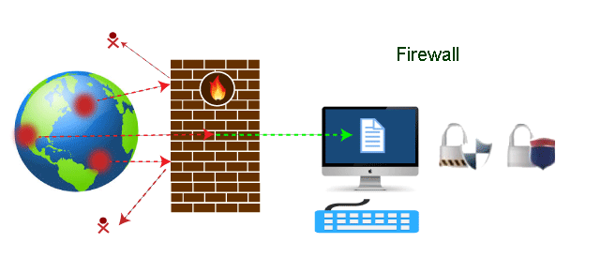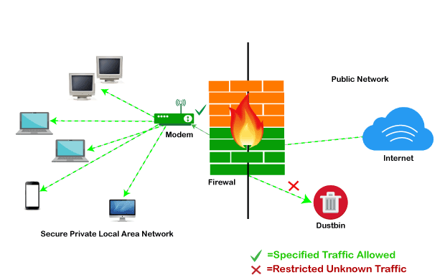

## **Functions of Firewall**

* Network Threat Prevention
* Application and Identity-Based Control
* Hybrid Cloud Support
* Scalable Performance
* Network Traffic Management and Control
* Access Validation
* Record and Report on Event

## **Types of Firewall**

Depending on their structure and functionality, there are different types of firewalls. The following is a list of some common types of firewalls:

* Proxy Firewall
* Packet-filtering firewalls
* Stateful Multi-layer Inspection (SMLI) Firewall
* Unified threat management (UTM) firewall
* Next-generation firewall (NGFW)
* Network address translation (NAT) firewalls

## **Limitations of Firewall**

* Firewalls cannot stop users from accessing malicious websites, making it vulnerable to internal threats or attacks.
* Firewalls cannot protect against the transfer of virus-infected files or software.
* Firewalls cannot prevent misuse of passwords.
* Firewalls cannot protect if security rules are misconfigured.
* Firewalls cannot protect against non-technical security risks, such as social engineering.
* Firewalls cannot stop or prevent attackers with modems from dialing in to or out of the internal network.
* Firewalls cannot secure the system which is already infected.

**Difference bw Hardware and Software Firewall**

|  |  |  |
| --- | --- | --- |
| **Aspect** | **Hardware Firewall** | **Software Firewall** |
| Implementation | Physical device (router, dedicated appliance) | Program or application installed on individual computers |
| Deployment | Installed at network perimeter | Installed on individual computers/servers |
| Performance & Scalability | High performance, scalable for large networks | Performance impact on host machine, suitable for small networks |
| Configuration & Management | Managed via web-based GUI or CLI provided by manufacturer | Managed on each individual computer/server |
| Cost & Complexity | Upfront hardware cost, potentially simpler deployment | Lower initial cost, potential complexity in management |
| Protection Scope | Provides centralized protection for entire network | Provides localized protection for individual devices |
| Network Impact | Minimal impact on network performance | May impact host machine performance |

**IDS**

IDS stands for Intrusion Detection System. It's a security tool used to monitor network or system activities for malicious activities or policy violations. The primary function of an IDS is to detect and alert administrators or security personnel about potential threats or security breaches in real-time.

**IPS**

An Intrusion Prevention System (IPS) is like a security guard with superpowers for your computer network or system.While an Intrusion Detection System (IDS) acts like a watchful eye, noticing when something suspicious happens, an IPS goes a step further—it actively stops any suspicious or malicious activity in its tracks before it can cause harm.

**What is Inbound and Outbound rules in firewall**

1. **+Inbound Rules**:
   * Inbound traffic refers to data packets coming from external sources (outside the network) and destined for devices within the network.
   * Inbound rules specify what types of incoming traffic are allowed or blocked by the firewall. These rules dictate whether incoming traffic is permitted to reach specific devices, services, or ports within the network.
   * For example, an inbound rule might allow incoming HTTP (web) traffic on port 80 to reach a web server within the network, while blocking all other inbound traffic.
2. **Outbound Rules**:
   * Outbound traffic refers to data packets originating from devices within the network and destined for external sources (outside the network).
   * Outbound rules specify what types of outgoing traffic are allowed or blocked by the firewall. These rules control which devices within the network are allowed to communicate with external services or destinations.
   * For example, an outbound rule might allow outgoing SMTP (email) traffic on port 25 from an email server within the network to reach external email servers, while blocking all other outbound traffic.

**NETWORK TROUBLESHOOTING**

Network troubleshooting is the process of identifying, diagnosing, and resolving problems or issues that occur within a computer network. It involves systematically analyzing network components, protocols, and configurations to pinpoint the root cause of connectivity issues, performance degradation, or other network-related problems.

1. **Identifying Symptoms**: The first step in network troubleshooting is to identify the symptoms or indicators of a problem. This may include slow network performance, intermittent connectivity issues, error messages, or complete network outages. Users or administrators may report these symptoms, or they may be detected through network monitoring tools or diagnostic utilities.
2. **Gathering Information**: Once symptoms are identified, gather relevant information about the network environment, including network topology, hardware configurations, IP addresses, subnet masks, and routing tables. Collect information from affected users, review network documentation, and use diagnostic tools to gather data about network traffic, performance metrics, and error logs.
3. **Isolating the Problem**: Narrow down the scope of the problem by isolating the affected network segments, devices, or services. Determine whether the issue is localized to a specific area of the network, such as a single device, subnet, or network link. Use techniques such as ping tests, traceroute, and network monitoring to trace the path of network traffic and identify points of failure.
4. **Analyzing Potential Causes**: Once the problem is isolated, analyze potential causes based on the symptoms observed and the information gathered. Common causes of network problems include hardware failures, software bugs, misconfigurations, network congestion, security breaches, and environmental factors such as interference or power outages.
5. **Testing and Verification**: Conduct tests and experiments to verify hypotheses and test potential solutions. Use diagnostic tools and utilities to perform network tests, packet captures, and configuration checks. Verify connectivity, routing, and service availability by testing communication between devices, checking network interfaces, and validating network configurations.
6. **Implementing Solutions**: Based on the analysis and testing, implement solutions to address the identified problem. This may involve reconfiguring network devices, updating firmware or software, replacing faulty hardware components, optimizing network settings, or implementing security measures to mitigate vulnerabilities.
7. **Documenting Resolution**: Document the troubleshooting process, including the symptoms observed, diagnostic steps taken, potential causes identified, and solutions implemented. Maintain records of network configurations, changes made, and lessons learned for future reference. Documenting the resolution helps in knowledge sharing, troubleshooting recurring issues, and improving network reliability and performance over time.

Network troubleshooting typically involves a systematic approach to identify, diagnose, and resolve common network problems. Here's a basic step-by-step guide to network troubleshooting:

1. **Check Physical Connections**:
   * Verify that all network cables are securely connected and not damaged.
   * Ensure that network devices (routers, switches, modems, etc.) are powered on and functioning properly.
   * Check for any physical damage or loose connections that may be affecting network connectivity.
2. **Verify Network Configuration**:
   * Check the network configuration settings on devices such as computers, routers, and switches.
   * Ensure that IP addresses, subnet masks, default gateways, and DNS server settings are configured correctly.
   * Use the "ipconfig" command (on Windows) or "ifconfig" command (on Linux/Unix) to view and verify network configuration details.
3. **Ping Test**:
   * Use the ping command to test connectivity between devices on the network and external resources such as websites or servers.
   * Ping a known IP address within the local network to test internal connectivity.
   * Ping an external IP address (e.g., 8.8.8.8) to test connectivity to the internet.
   * If pinging fails, check for firewall rules, routing issues, or DNS resolution problems.
4. **Check Network Devices**:
   * Check the status lights on network devices (routers, switches, etc.) to verify connectivity and activity.
   * Access the web interface or command-line interface (CLI) of network devices to check their configuration and status.
   * Look for any error messages, warnings, or logs that may indicate problems with network devices or services.
5. **Restart Network Devices**:
   * Sometimes, simply restarting network devices can resolve temporary connectivity issues.
   * Power cycle routers, switches, modems, and other network devices by unplugging them, waiting a few seconds, and then plugging them back in.
   * Allow the devices to reboot and reconnect to the network, then retest connectivity.
6. **Check Firewall and Security Settings**:
   * Review firewall settings on routers, switches, and computers to ensure that they are not blocking network traffic.
   * Check security software (firewalls, antivirus programs) on computers for any settings that may be interfering with network connectivity.
   * Temporarily disable firewall or security software to see if it resolves the issue, but remember to re-enable it afterward.
7. **Update Network Drivers and Firmware**:
   * Ensure that network adapter drivers on computers are up-to-date. Check the manufacturer's website for the latest drivers and install any available updates.
   * Check for firmware updates for routers, switches, and other network devices. Updating firmware can address known bugs, vulnerabilities, and compatibility issues.

**Basic Troubleshooting Commands**

**PING**

PING stands for "Packet Internet Groper.

The ping command is a network utility used to test the reachability of a host on an Internet Protocol (IP) network and measure the round-trip time for messages sent from the originating host to a destination computer. Here's how to use the ping command:

* **Open Command Prompt (Windows) or Terminal (macOS/Linux)**:
  1. On Windows: Press Win + R, type "cmd", and press Enter.
  2. On macOS: Open Spotlight (Cmd + Space), type "Terminal", and press Enter.
  3. On Linux: Open the Terminal from the Applications menu or use the keyboard shortcut Ctrl + Alt + T.
* **Type the Ping Command**:
  1. Syntax: ping [destination]
  2. Replace [destination] with the IP address or domain name of the target host you want to ping.
  3. For example, to ping the Google DNS server (8.8.8.8), type ping 8.8.8.8.
  4. You can also ping a domain name, such as ping [www.google.com](http://www.google.com).

1. **IPCONFIG**

The ipconfig command is a Windows command-line utility used to display network configuration information for a computer running the Windows operating system. It provides details about the computer's IP address, subnet mask, default gateway, DNS servers, and other network-related information.

1. **Open Command Prompt**:
   * Press Win + R, type "cmd", and press Enter to open the Command Prompt.
2. **Type the ipconfig Command**:
   * In the Command Prompt window, type ipconfig and press Enter.
   * This will display a list of network interfaces and their associated configuration details.
3. **View Network Configuration**:
   * The output of the ipconfig command includes information such as:
     + IPv4 Address: The computer's IP address assigned by the network.
     + Subnet Mask: The subnet mask used to identify the network portion of the IP address.
     + Default Gateway: The IP address of the default gateway or router used for routing network traffic.
     + DNS Servers: The IP addresses of the DNS (Domain Name System) servers used for domain name resolution.
     + Physical Address (MAC Address): The hardware address of the network adapter.
4. **Additional Options**:
   * You can use various options with the ipconfig command to display specific information or perform additional tasks:
     + ipconfig /all: Displays detailed information for all network interfaces, including physical and virtual adapters.
     + ipconfig /release: Releases the IP address lease obtained from a DHCP server.
     + ipconfig /renew: Renews the IP address lease from a DHCP server.
     + ipconfig /flushdns: Flushes the DNS resolver cache, clearing stale DNS records.
5. **NETSTAT**

The netstat command is a network utility available in various operating systems, including Windows, macOS, and Linux. It is used to display information about network connections, routing tables, interface statistics, and network protocols.

1. **Open Command Prompt or Terminal**:
   * On Windows: Press Win + R, type "cmd", and press Enter.
   * On macOS/Linux: Open Terminal from the Applications menu or use the keyboard shortcut Ctrl + Alt + T.
2. **Type the netstat Command**:
   * Syntax: netstat [options]
   * Without any options, the netstat command displays a list of active network connections and listening ports.
   * For example, to display all active TCP connections, type netstat -a (on Windows) or netstat -at (on macOS/Linux).
3. **View Network Information**:
   * The output of the netstat command includes information such as:
     + Local Address: The local IP address and port number of the connection.
     + Foreign Address: The remote IP address and port number of the connection.
     + State: The current state of the connection (e.g., ESTABLISHED, TIME_WAIT, LISTENING).
     + Proto: The protocol used by the connection (e.g., TCP, UDP).
     + PID/Program Name: The process ID and name of the program associated with the connection.
4. **Additional Options**:
   * You can use various options with the netstat command to display specific information or perform additional tasks:
     + -a: Displays all active connections and listening ports.
     + -t (or --tcp): Displays TCP connections.
     + -u (or --udp): Displays UDP connections.
     + -n (or --numeric): Displays numerical addresses instead of resolving hostnames.
     + -r (or --route): Displays the kernel routing table.
     + -p (or --program): Displays the PID and name of the program associated with each connection.
     + -s (or --statistics): Displays network interface statistics.
5. **ARP**

The arp command is a network utility used to display and manipulate the Address Resolution Protocol (ARP) cache, which maps IP addresses to MAC addresses on a local network. ARP is a protocol used by network devices to discover the hardware (MAC) address associated with a given IP address.

1. **Open Command Prompt or Terminal**:
   * On Windows : Press Win + R, type "cmd", and press Enter.
   * On macOS/Linux: Open Terminal from the Applications menu or use the keyboard shortcut Ctrl + Alt + T.
2. **Type the arp Command**:
   * Syntax: arp [options] [hostname]
   * Without any options, the arp command displays the ARP cache, which contains mappings of IP addresses to MAC addresses.
   * For example, to display the ARP cache, type arp -a (on Windows) or arp -n (on macOS/Linux).
3. **View ARP Cache**:
   * The output of the arp command includes information such as:
     + Interface: The network interface associated with the ARP entry.
     + Internet Address: The IP address of the device.
     + Physical Address: The MAC address of the device.
     + Type: The type of ARP entry (dynamic or static).
4. **Additional Options**:
   * You can use various options with the arp command to display specific information or perform additional tasks:
     + -a (or -n): Displays the ARP cache.
     + -d [hostname]: Deletes an ARP entry for the specified hostname.
     + -s [hostname] [mac_address]: Adds a static ARP entry mapping the specified hostname to the specified MAC address.
     + -g [hostname]: Displays the MAC address associated with the specified hostname.
     + -? (or /?): Displays help information about the arp command.

6. **NSLOOKUP**

The nslookup command is a network utility used to query the Domain Name System (DNS) to obtain information about domain names, IP addresses, and DNS records. It's available on various operating systems, including Windows, macOS, and Linux.

1. **Open Command Prompt or Terminal**:
   * On Windows: Press Win + R, type "cmd", and press Enter.
   * On macOS/Linux: Open Terminal from the Applications menu or use the keyboard shortcut Ctrl + Alt + T.
2. **Type the nslookup Command**:
   * Syntax: nslookup [hostname]
   * Replace [hostname] with the domain name or IP address you want to query.
   * For example, to look up the IP address of a domain name (e.g., google.com), type nslookup google.com.
3. **View DNS Information**:
   * The output of the nslookup command includes information such as:
     + Name: The domain name or hostname being queried.
     + Address: The corresponding IP address (IPv4 or IPv6) associated with the domain name.
     + Non-authoritative answer: Indicates whether the DNS server providing the response is authoritative for the domain.
     + Other DNS records: Additional information such as MX (mail exchange) records, NS (name server) records, etc.
4. **Additional Options**:
   * You can use various options with the nslookup command to perform specific tasks or customize the output:
     + -query=[type]: Specifies the type of DNS record to query (e.g., A, AAAA, MX, NS).
     + -type=[type]: Same as -query, specifies the type of DNS record to query.
     + -debug: Enables debug mode, providing more detailed information about the DNS query process.
     + -timeout=[seconds]: Specifies the timeout value for DNS queries in seconds.
     + -port=[port]: Specifies the DNS server port to query (default is port 53).
     + -help: Displays help information about the nslookup command.

7. **TRACERT**

The tracert command is a network diagnostic tool used to trace the route that data packets take from the local computer to a specified destination host or IP address. It's available on various operating systems, including Windows, macOS, and Linux

• **Open Command Prompt or Terminal**:

* On Windows: Press Win + R, type "cmd", and press Enter.
* On macOS/Linux: Open Terminal from the Applications menu or use the keyboard shortcut Ctrl + Alt + T.

• **Type the tracert Command**:

* Syntax: tracert [destination]
* Replace [destination] with the domain name or IP address you want to trace the route to.
* For example, to trace the route to google.com, type tracert google.com.

• **View Traceroute Results**:

* The output of the tracert command displays a list of network hops (routers or gateways) along the path to the destination, along with information such as:
  + Hop number: Sequential number indicating the order of network hops.
  + IP address: IP address of the router or gateway at each hop.
  + Round-trip time (RTT): Time taken for a packet to travel from the local computer to the router and back, measured in milliseconds.
  + Hostname: Hostname (if available) corresponding to the IP address.

• **Interpret Traceroute Results**:

* Each line of the traceroute output represents a network hop along the path to the destination.
* Traceroute identifies the IP addresses of intermediate routers or gateways that forward packets towards the destination.
* The RTT values indicate the latency or delay experienced at each network hop.
* Traceroute may display asterisks (*) for hops that don't respond or timeout, indicating potential network congestion or firewall restrictions.

• **Additional Options**:

* You can use various options with the tracert command to customize the traceroute behavior or display additional information:
  + -d: Performs a traceroute without attempting to resolve hostnames to IP addresses.
  + -h [max_hops]: Specifies the maximum number of hops to trace.
  + -w [timeout]: Specifies the maximum time (in milliseconds) to wait for a response at each hop.
  + -4 or -6: Forces traceroute to use IPv4 or IPv6, respectively.
  + -? or --help: Displays help information about the tracert command.

**SPLICING**

Splicing refers to the process of joining two or more cables or fibers together to create a continuous connection. It is commonly used in telecommunications, networking, and electrical engineering for various purposes, such as extending cable lengths, repairing damaged cables, or connecting different types of cables.

**Tools**

The tools required for splicing depend on the type of splicing being performed, whether it's for fiber optics, electrical wiring, or other applications. Below are some common tools used for different types of splicing:

* **Fusion Splicer**: A fusion splicer is a specialized device used to precisely align and fuse the ends of optical fibers together.
* **Cleaver**: A fiber cleaver is used to precisely score and cleave (cut) optical fibers at a 90-degree angle before splicing.
* **Fiber Strippers**: Fiber strippers are used to remove the protective coating from optical fibers before cleaving.
* **Alcohol and Wipes**: Alcohol and lint-free wipes are used for cleaning the fiber ends before splicing to ensure proper fusion.
* **Splice Trays and Sleeves**: Splice trays and protective sleeves are used to protect and organize the spliced fibers after fusion.
* **Visual Fault Locator (VFL)**: A VFL is used to visually identify faults or breaks in the fiber optic cable before splicing.
* **Fiber Optic Identifier**: This tool helps identify active fibers within a cable to avoid accidental damage during splicing.
* **Wire Strippers**: Wire strippers are used to remove the insulation from electrical wires before splicing.
* **Wire Cutters**: Wire cutters are used to cut wires to the required length for splicing.
* **Crimping Tool**: A crimping tool is used to crimp connectors onto the ends of wires after splicing.
* **Heat Shrink Tubing**: Heat shrink tubing is used to insulate and protect the spliced wires after soldering.

**EST OF NETWORK IN INF BN**

**Benefits of Est LAN in Inf Bn**

A Local Area Network (LAN) offers several benefits for organizations and users, facilitating communication, collaboration, and resource sharing within a confined geographic area. Here are some of the key benefits of LAN:

1. **Resource Sharing**: LANs allow users to share resources such as printers, files, applications, and internet connections within the network. This promotes efficiency and reduces costs by eliminating the need for individual resources for each user or device.
2. **Communication**: LANs enable fast and reliable communication between devices connected to the network. Users can easily exchange messages, share files, and collaborate on projects using email, instant messaging, file sharing, and other communication tools.
3. **Centralized Data Storage**: LANs often include file servers or network-attached storage (NAS) devices where users can centrally store and access shared data. Centralized data storage improves data management, backup, and security by ensuring that important files are stored in a controlled and accessible location.
4. **Security**: LANs allow organizations to implement security measures such as firewalls, antivirus software, access controls, and encryption to protect sensitive data and resources from unauthorized access, malware, and cyber threats. LANs also enable network administrators to monitor and manage network security centrally.
5. **Scalability**: LANs can easily scale to accommodate growing numbers of users, devices, and services. Organizations can expand their LAN infrastructure by adding additional network switches, access points, and other networking components as needed to support increasing demands for network resources and connectivity.
6. **Performance**: LANs provide high-speed connectivity and low latency, enabling fast data transfer and efficient access to network resources. This is particularly beneficial for bandwidth-intensive applications such as multimedia streaming, video conferencing, and real-time collaboration tools.
7. **Flexibility**: LANs offer flexibility in terms of network design, topology, and configuration. Organizations can choose from various network architectures (e.g., Ethernet, Wi-Fi, fiber optic) and topologies (e.g., star, bus, ring) to suit their specific requirements and infrastructure constraints.
8. **Improved Collaboration**: LANs facilitate collaboration among users by enabling real-time communication, file sharing, and access to shared resources. Users can work together on projects, share documents, and collaborate on tasks more effectively, regardless of their physical location within the LAN.

**Reqmt for Est LAN in Inf Bn**

* Hardware Components
  + Devices (computers, laptops, servers, printers, switches, NAS)
  + Network Interface Cards (NICs)
  + Cables and Connectors (Ethernet cables, such as Cat5e or Cat6)
  + Network Cabinets & Racks (Provide a centralized location for devices like switches, ensuring proper cable management)
* **Software Components**
  + Network Operating System (Win Server 2012, 2016, 2019, 2022)
  + Network Protocols (TCP/IP, ICMP, FTP)
  + Network Management Software (Nw monitoring, performance optimization, & configuration management)
  + Network Security Software (Firewalls, antivirus software)
* **Users**
  + Network Users
  + Network Administrator

**LAYOUT**

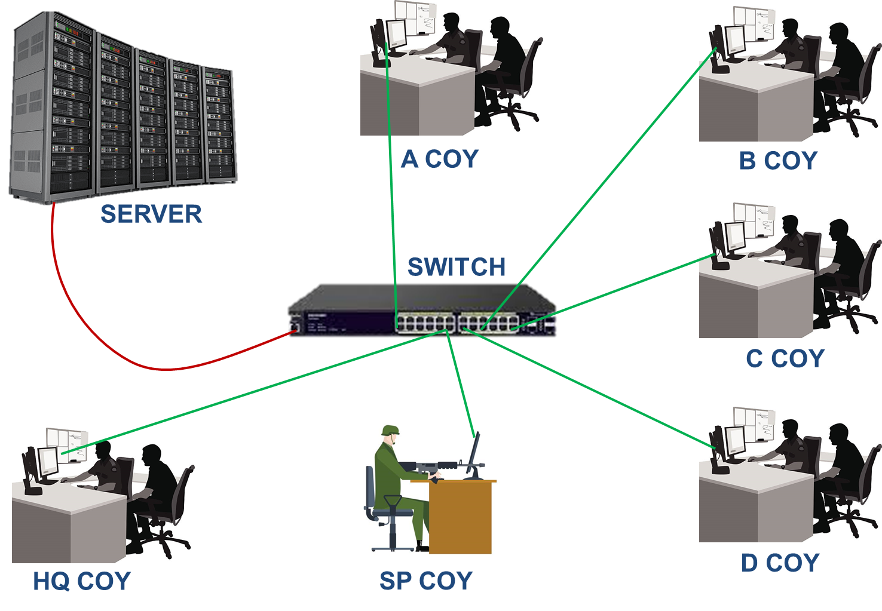

|  |  |  |
| --- | --- | --- |
| **Aspect** | **Wired LAN** | **Wireless LAN** |
| Connectivity | Uses physical Ethernet cables for connection | Utilizes wireless radio signals for connection |
| Installation | Requires cable installation and infrastructure | Requires wireless access points (APs) for coverage |
| Mobility | Devices are stationary, limited mobility | Provides mobility, devices can move within coverage |
| Speed | Typically offers higher data transfer speeds | Generally lower data transfer speeds compared to wired |
| Reliability | Generally more reliable with consistent performance | Susceptible to interference, signal degradation |
| Security | Less susceptible to interception and eavesdropping | Requires encryption and security measures for protection |
| Scalability | Can be more challenging to scale and expand | Easier to scale and expand coverage with additional APs |
| Interference | Less susceptible to interference from external factors | Susceptible to interference from other wireless devices, obstructions |
| Cost | Initial setup costs may be higher due to cabling | Initial setup costs may be lower, but additional APs may increase cost |
| Flexibility | Offers less flexibility in terms of device placement | Provides flexibility in device placement and network access |
| Compatibility | Compatible with a wide range of devices and equipment | Compatible with devices equipped with wireless capabilities |

**Topology**

In networking, topology refers to the arrangement or layout of connected devices (nodes) and the links (connections) between them within a network. It defines how devices are interconnected and how data flows between them. There are several types of network topologies, each with its own advantages, disadvantages, and characteristics. Here's an overview of some common network topologies:

1. **Star Topology**:
   * In a star topology, all devices are connected to a central device, such as a hub or switch.
   * Each device has a dedicated point-to-point connection to the central device.
   * Data traffic flows through the central device, which manages communication between devices.
   * Advantages: Easy to install and manage, scalable, failure of one device does not affect others.
   * Disadvantages: Dependency on central device, single point of failure.
2. **Bus Topology**:
   * In a bus topology, all devices are connected to a single communication line or "bus."
   * Devices share the same communication medium and transmit data in both directions.
   * Data is broadcasted to all devices on the network, and only the intended recipient accepts the data.
   * Advantages: Simple and inexpensive, easy to add or remove devices.
   * Disadvantages: Susceptible to signal degradation and collisions, limited scalability, single point of failure.
3. **Ring Topology**:
   * In a ring topology, devices are connected in a closed loop or ring configuration.
   * Each device is connected to two neighboring devices, forming a continuous ring.
   * Data circulates around the ring in one direction, with each device forwarding the data to the next device.
   * Advantages: Balanced traffic distribution, no collisions, simple to install.
   * Disadvantages: Ring can be disrupted if one device fails, difficult to add or remove devices without disrupting the network.
4. **Mesh Topology**:
   * In a mesh topology, every device is connected to every other device in the network.
   * Each device has a point-to-point connection with every other device, creating multiple paths for data transmission.
   * Data can take different routes to reach its destination, improving reliability and fault tolerance.
   * Advantages: High redundancy, fault tolerance, scalable, no single point of failure.
   * Disadvantages: Complex and expensive to implement, requires more cabling and configuration.
5. **Hybrid Topology**:
   * A hybrid topology is a combination of two or more basic topologies, such as star-bus, star-ring, or star-mesh.
   * Combining different topologies allows for flexibility in network design and optimization based on specific requirements.
   * Advantages and disadvantages depend on the specific combination of topologies used.

**NETWORK TERMINOLOGY**

**Bandwidth measures units**

1. **Bit** - Binary digit, either 0 or 1
2. **Bit rate** – Data transmission speed – bits per second
3. **Mbps** – millions of bits per second
4. **8** **bits** = 1 byte
5. **Mb** – million bits (quantity of data)
6. **MB** – million bytes (quantity of data)
7. **GBPS** – Giga bits per second (data speed)
8. **Teraflops** – trillion operations per second

**Node.**

Any device connected to the network, usually a computer, but it could be a printer or a scanner.

**Bandwidth.**

The internet consists of tens of millions of computers throughout the world, all connected by cables. If you've ever wondered why it takes so long to download certain web pages or other files to your computer. It's all determined by the bandwidth of the connection between your computer and your internet service provider (rate of data transfer per second).

**Broadband.**

Narrowband is usually referred to dial up internet connection and it usually varies from speeds of about 50 characters per second to about 60 kbps. Broadband is usually regarded as any internet connection that can deliver speeds faster than 60 kbps.

**Domain name.**

The unique name that identifies an Internet site. It has 2 or more parts, separated by dots.Internet is based on IP addresses, not domain names, web servers depend on a Domain Name System (DNS) to translate domain names into IP addresses. Simply stated, domain names allow people to find your web site by name rather than by its numerical (IP) address.

**Domain name system (DNS)**

The network service used in TCP/IP networks that translates host names to IP address. For example, when a web address is typed into a browser, DNS servers return the IP address of the web server associated with that name.

**Protocol.**

Set of rules or standards. Enables computers to connect with one another. Enables exchange of information without error. Example: protocol can define the way in which two programs transfer a file across the internet. Protocol generally accepted for standardizing communication is seven layer OSI model.

**DHCP (dynamic host configuration protocol).**

It is a communication protocol that lets administrator centrally manage and automate the assignment of IP addresses in an org network.Without DHCP, IP addresses must be entered manually at each time a computer moves to new loc.DHCP automatically releases IP for all computers connected to a network. The IP addresses releases by DHCP is valid on basis of the lease duration.

**DHCP** **SERVER**.

A computer running the DHCP Server service that holds information about available IP addresses and related configuration information as defined by the DHCP administrator and responds to requests from DHCP clients.

**DHCP** **CLIENT.**

A computer that gets its IP configuration information by using DHCP.

**SCOPE.**

A range of IP addresses that are available to be leased to DHCP clients by the DHCP Server service.

**SUBNETTING**.

The process of partitioning a single TCP/IP network into a number of separate network segments called subnets**.2**

**DHCP OPTION.**

Configuration parameters that a DHCP server assigns to clients. Most DHCP options are predefined, based on optional parameters defined in Request for Comments (RFC) 2132, although extended options can be added by vendors or users.

**OPTION CLASS.**

An additional set of options that can be provided to a DHCP client based on its computer class membership. The administrator can use option classes to sub manage option values provided to DHCP clients. There are two types of options classes supported by a DHCP server running Windows Server 2003: vendor classes and user classes.

**RESERVATION.**

A specific IP address within a scope permanently set aside for leased use by a specific DHCP client. Client reservations are made in the DHCP database using the DHCP snap-in and are based on a unique client device identifier for each reserved entry.

**EXCLUSION/EXCLUSION RANGE.**

One or more IP addresses within a DHCP scope that are not allocated by the DHCP Server service. Exclusions ensure that the specified IP addresses will not be offered to clients by the DHCP server as part of the general address pool.

**MULTICAST IP ADDRESSES.**

Multicast IP addresses allow multiple clients to receive data that is sent to a single IP address, enabling point-to-multipoint communication. This type of transmission is often used for streaming media transmissions, such as video conferencing.

**MULTICAST SCOPE.**

A range of multicast IP addresses that can be assigned to DHCP clients. A multicast scope allows dynamic allocation of multicast IP addresses for use on the network by using the MADCAP protocol, as defined in RFC 2730.

**IP Address.**

A unique number used to specify hosts and networks.Internet Protocol (IP) numbers are used for identifying machines that are connected to the Internet.They are sometimes called a dotted quad and are unique numbers consisting of 4 parts separated by dots.

Eg 216.119.81.205

Every machine has a unique IP number - if not, it is not really on the Internet.

**Fiber Optic.**

A type of network cable that uses a central glass or plastic core surrounded by a plastic coating.

**Alias**.

A name that points to another name. Aliases are used to make the original name easier to remember or to protect the site's identity.

**PING (Packet Internet Gopher)**.

A TCP/IP utility used to test whether another host is reachable. A request is sent to the host, who responds with a reply if it is reachable. The request timed out if the host is not reachable.

**POP3.**

The post office protocol version 3 pop3 is intended to permit a workstation to dynamically access a mail drop on a server host. It is usually used to allow a workstation to retrieve mail that the server is holding for it. Pop3 uses port.

**SUBNET MASK.**

A subnet mask is a 32 bit number that is used to partition IP addresses into a network ID and a host ID. Subnet masks are used by **TCP/IP** services and application to determine whether a given IP address on an interwork is a local network address or a remote network address.

**SERVER.**

Server is a high configuration computer which provides services to all clients. A computer that provides resources to the clients on the network.

**CLIENT.**

Client is a normal configuration computer which has taken services from server.

**ADDS.**

Active Directory Domain Service (ADDS) stores information about users, computers and other devices on the network. It helps administrators securely manage these info and facilitates resource sharing and collaboration between users. It is also required for Microsoft Exchange server tech. ADDS requires DNS server to be installed.

**Web Server.**

Web servers are computers that lets you to share info over the internet, through internets and intranets. Web server include internet information services (IIS) 8.0 with enhanced security, diagnostic and administration. It is a unified platform that integrates IIS 8.0, ASP.net and windows common foundation.